**Assignment – 6 (Distinct statement and Between, Not Between, IN operator)**

Write SQL command to perform the following:

1. Create a table called products(id, name, price, manufacturer)

**Constraints:**

* Name and Price are compulsory to fill.
* Each product’s price should be more than 100.
* Manufacturer should be ‘ABC’ if not given by the user.

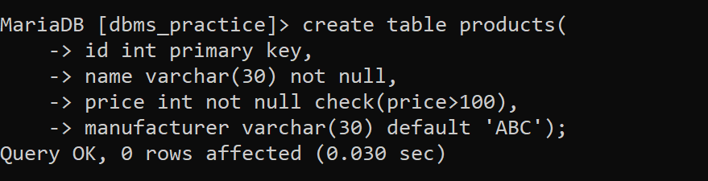

1. Insert at least 10 tuples with different data in the products table.

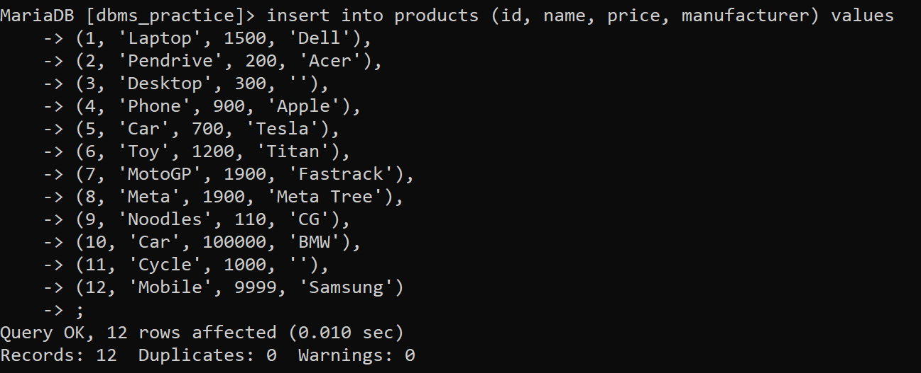

1. Select all the products whose price is between 400 to 800.

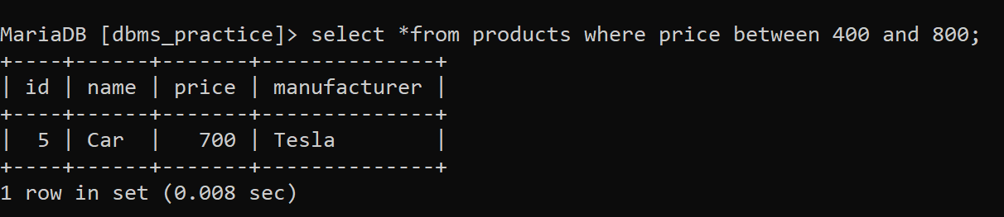

1. Select all the products whose price range is not in 200 to 300.

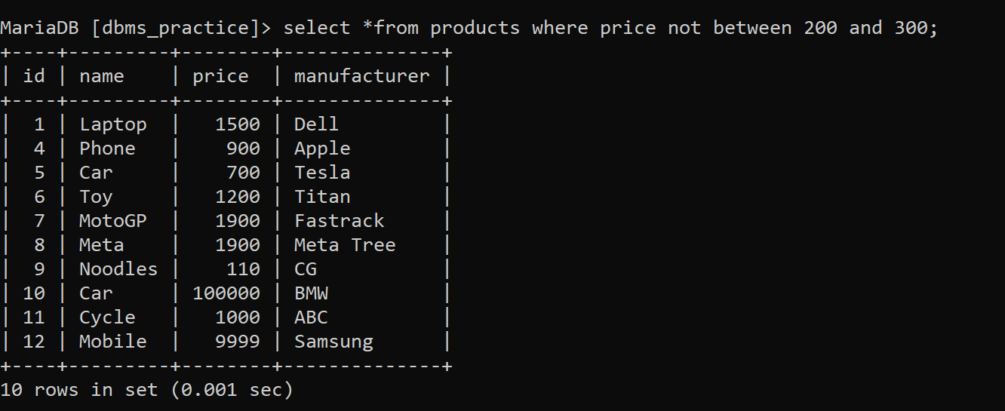

1. Select all the products whose manufacturer is ‘Dell’, ‘Acer’, ‘Asus’, ‘Apple’, ‘Tesla’, ‘Titan’ and ‘Fastrack’.

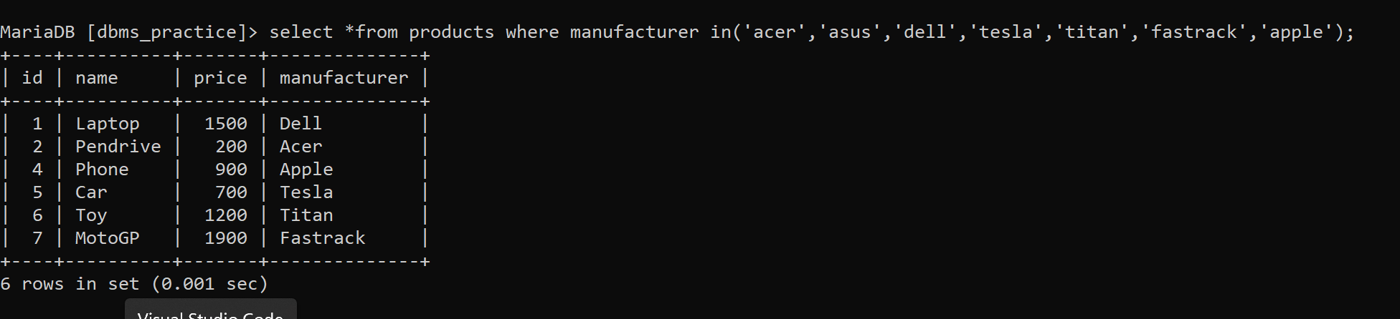

1. Select all the products which are not manufactured by ‘Meta Tree’, ‘CG’, and ‘BMW’.

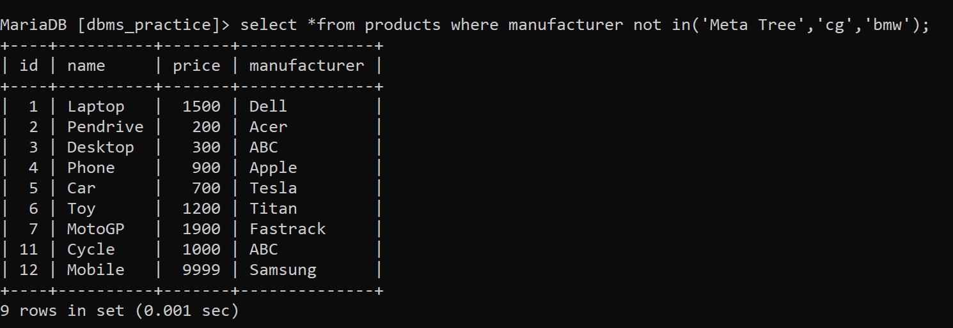

1. Change the price of the product to exactly 500 which contain ‘ap’ in their name.

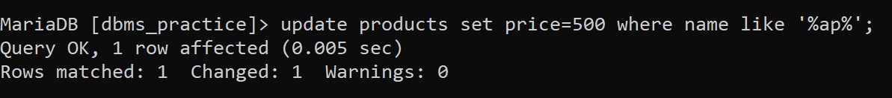

1. Select the products either having price more than 500 or is produced by ‘CG Group’.

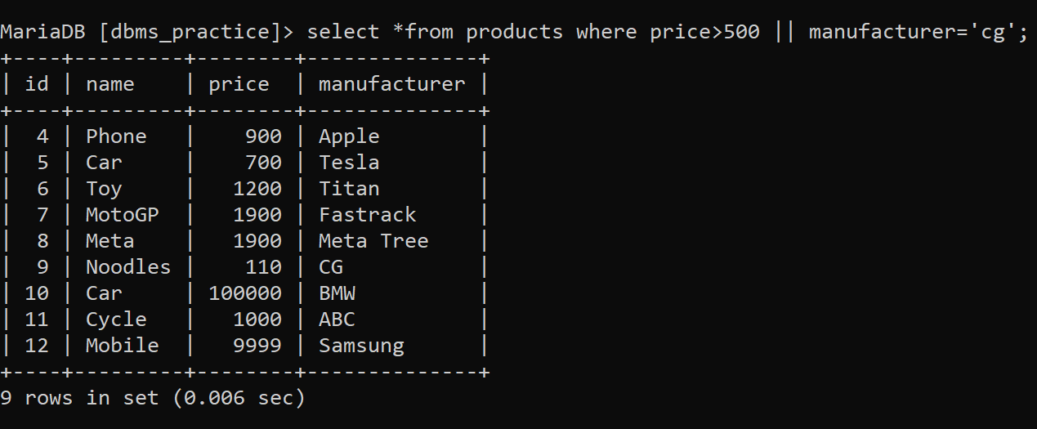

1. Select the products which have price in exactly three digits and name the column as Most_Demanded_Products.

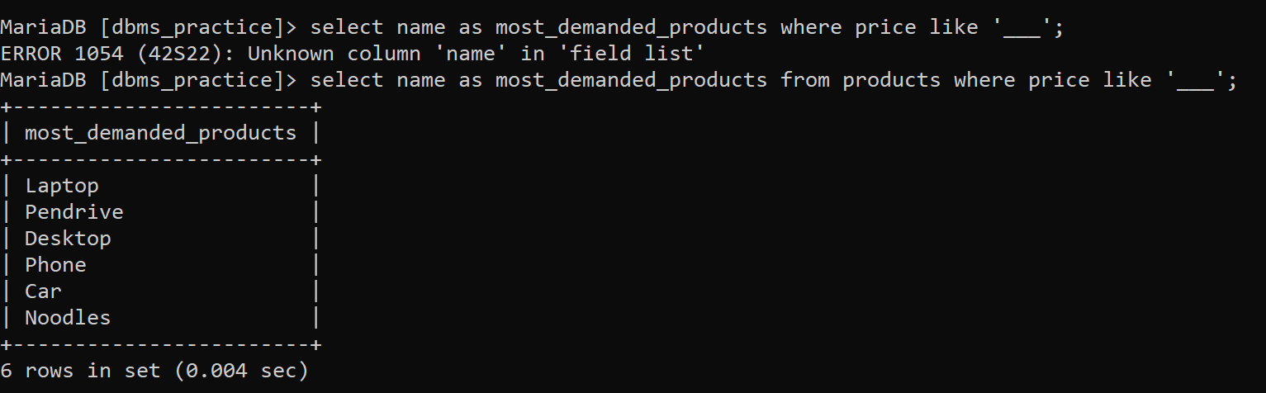

1. Create another table called product_copy having exact columns and data as product table.

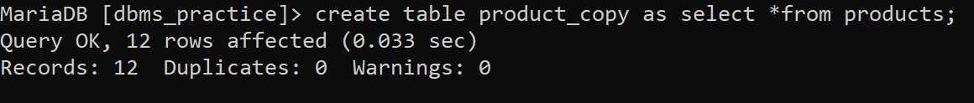

1. Display all the details of product_copy table.

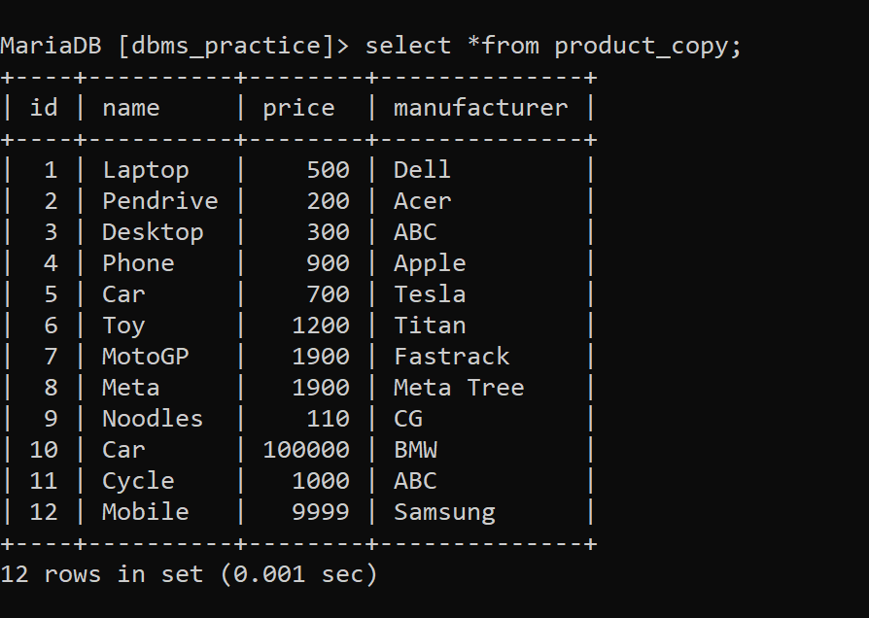

1. Select the entire manufacturer name but don’t repeat the same name.

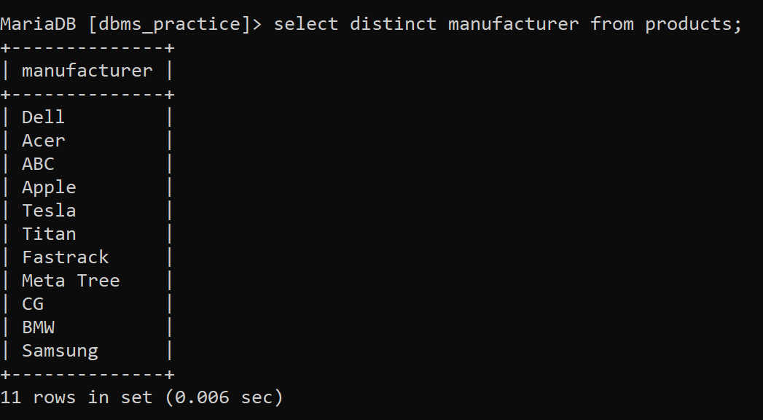

1. Select the products whose price is 500, 6000, 300, 900, 800, 1200, 1500, 400.

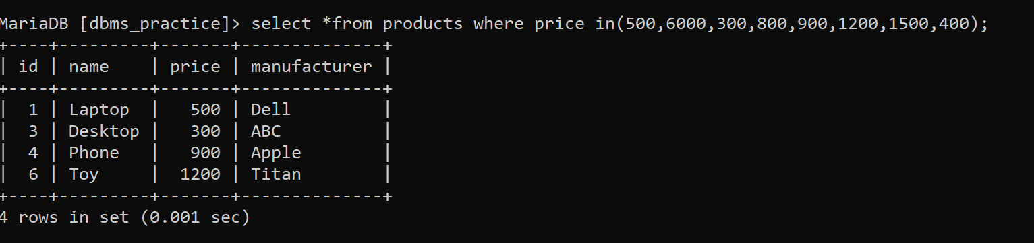

1. Select the products having names as candies, chips, chocolate and price is more than 500.



1. Delete the products manufactured by ‘Nestle’.

 